**Supporting Information**

**A Thermal Analysis and Physicochemical Study on Thermoresponsive Chimeric Liposomal Nanosystems**

Nikolaos Naziris1, Athanasios Skandalis2, Aleksander Forys3, Barbara Trzebicka3, Stergios Pispas2, Costas Demetzos1,*

1Section of Pharmaceutical Technology, Department of Pharmacy, School of Health Sciences, National and Kapodistrian University of Athens, Panepistimioupolis Zografou, 15771 Athens, Greece

2Theoretical and Physical Chemistry Institute, National Hellenic Research Foundation, 48 Vassileos Constantinou Avenue, 11635 Athens, Greece

3Centre of Polymer and Carbon Materials, Polish Academy of Sciences, 34 M. Curie-Skłodowskiej St., 41-819 Zabrze, Poland

*Corresponding author. Tel.: +30 2107274596; Fax: +30 2107274027; *E-mail* address: [demetzos@pharm.uoa.gr](mailto:demetzos@pharm.uoa.gr) (Prof. C. Demetzos)

**A.**

**B.**

**Figure S1:** Plot of transition specific enthalpy (*ΔΗm*) vs. concentration of the incorporated copolymer for the chimeric systems A. DPPC:PNIPAM-b-PLA 1 and B. DPPC:PNIPAM-b-PLA 2.

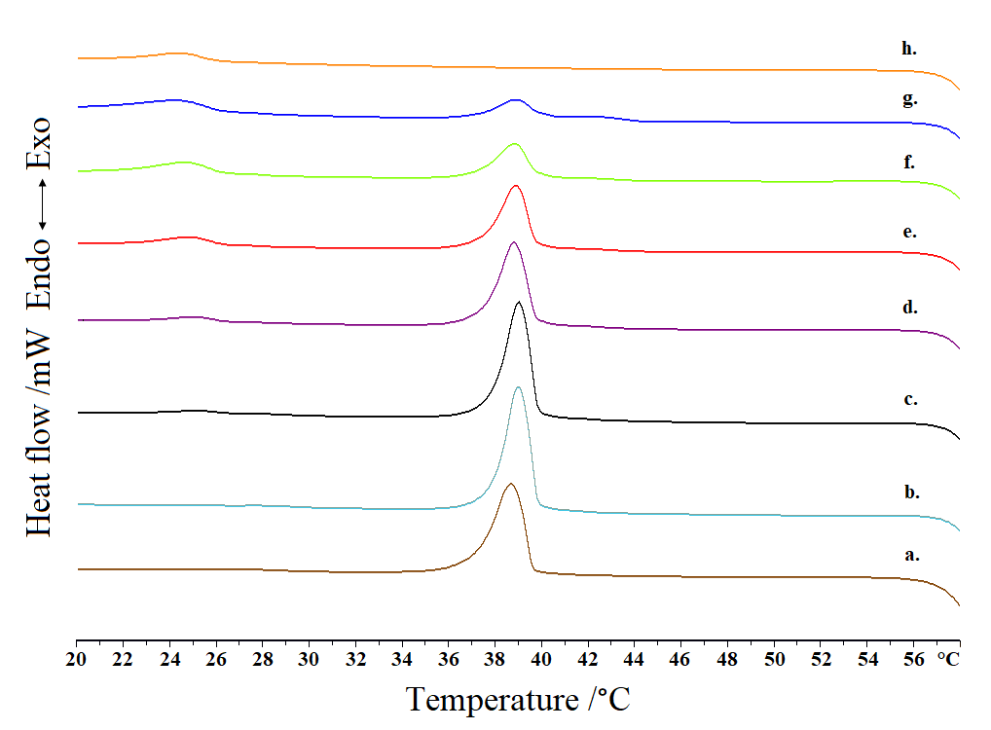

**Figure S2:** DPPC:PNIPAM-b-PLA 1 DSC cooling cycle for systems (a) DPPC and DPPC:PNIPAM-b-PLA 1 (b) 9:0.02, (c) 9:0.05, (d) 9:0.1, (e) 9:0.2, (f) 9:0.5, (g) 9:1 and (h) PNIPAM-b-PLA 1.

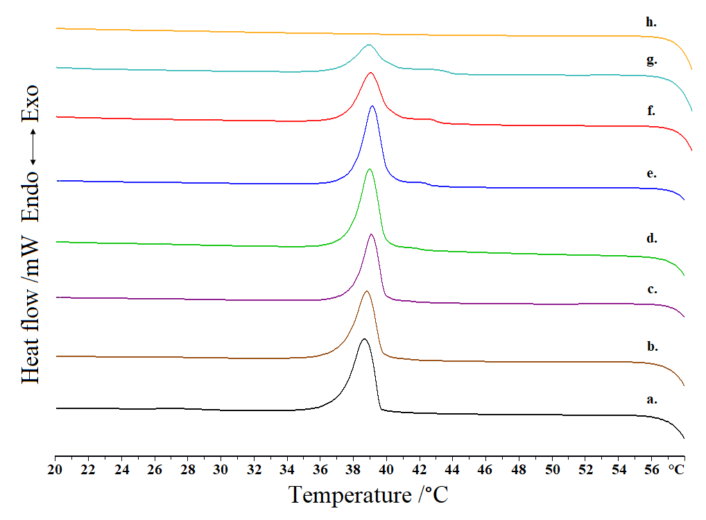

**Figure S3:** DPPC:PNIPAM-b-PLA 2 DSC cooling cycle for systems (a) DPPC and DPPC:PNIPAM-b-PLA 2 (b) 9:0.02, (c) 9:0.05, (d) 9:0.1, (e) 9:0.2, (f) 9:0.5, (g) 9:1 and (h) PNIPAM-b-PLA 2.

**A.**

**B.**

**Figure S4:** Stability assessment of A. DPPC conventional and DPPC:PNIPAM-b-PLA 1 and 2 and B. EPC conventional and EPC:PNIPAM-b-PLA 1 and 2 chimeric structures’ size.

**A.**

**B.**

**Figure S5:** Stability assessment of A. DPPC conventional and DPPC:PNIPAM-b-PLA 1 and 2 and B. EPC conventional and EPC:PNIPAM-b-PLA 1 and 2 chimeric structures’ polydispersity.



**A.**

**Room Temp**

**45°C**

**Sonication**



**B.**

**Room Temp**

**45°C**

**Sonication**



**C.**

**Room Temp**

**45°C**

**Sonication**



**D.**

**Room Temp**

**45°C**

**Sonication**

**Figure S6:** DLS intensity-weighted plots of nanoparticles in three different conditions for A. DPPC, B. DPPC:PNIPAM-b-PLA 1 9:0.02, C. DPPC:PNIPAM-b-PLA 1 9:0.05 and D. DPPC:PNIPAM-b-PLA 1 9:0.1.

**Table S1:** Calorimetric profiles of DPPC:PNIPAM-b-PLA 1 chimeric bilayers in PBS (pH = 7.4) (cooling cycle).

|  |  |  |  |  |  |  |  |  |  |
| --- | --- | --- | --- | --- | --- | --- | --- | --- | --- |
| **Sample** | **Molar Ratio** | **Tonset,m /°C** | **Tm /°C** | **ΔT1/2,m /°C** | **ΔHm /J g-1** | **Tonset,t /°C** | **Tt /°C** | **ΔT1/2,t /°C** | **ΔHt /J g-1** |
| Lipid | - | 39.91 | 39.11 | 1.50 | 47.32 | - | - | - | - |
| Chimeric | 9:0.02 | 40.13 | 39.39 | 1.19 | 52.59 | - | - | - | - |
| Chimeric | 9:0.05 | 40.17 | 39.50 | 1.20 | 50.21 | 26.85 | 25.54 | 1.82 | 1.64 |
| Chimeric | 9:0.1 | 40.06 | 39.18 | 1.33 | 41.07 | 26.65 | 25.27 | 1.99 | 2.87 |
| Chimeric | 9:0.2 | 40.05 | 39.22 | 1.31 | 31.46 | 26.57 | 25.02 | 2.19 | 5.74 |
| Chimeric | 9:0.5 | 40.11 | 39.09 | 1.52 | 20.49 | 26.53 | 24.94 | 2.42 | 8.05 |
| Chimeric | 9:1 | 40.41 | 39.25 | 1.68 | 14.90 | 26.49 | 24.55 | 3.03 | 9.65 |
| Polymer | - | - | - | - | - | 24.69 | 24.69 | 2.39 | 6.53 |

*Tonset*: temperature at which the thermal event starts; *T*: temperature at which heat capacity (*ΔCp*) at constant pressure is maximum; *ΔT1/2*: width at half peak height of the transition; *ΔH*: transition enthalpy normalized per gram of chimeric system. m: main transition; t: thermoresponsive transition

**Table S2:** Calorimetric profiles of DPPC:PNIPAM-b-PLA 2 chimeric bilayers in PBS (pH = 7.4) (cooling cycle).

|  |  |  |  |  |  |
| --- | --- | --- | --- | --- | --- |
| **Sample** | **Molar Ratio** | **Tonset,m /°C** | **Tm /°C** | **ΔT1/2,m /°C** | **ΔHm /J g-1** |
| Lipid | - | 39.91 | 39.11 | 1.50 | 47.32 |
| Chimeric | 9:0.02 | 40.01 | 39.14 | 1.40 | 43.20 |
| Chimeric | 9:0.05 | 40.19 | 39.41 | 1.14 | 34.09 |
| Chimeric | 9:0.1 | 40.22 | 39.36 | 1.29 | 46.92 |
| Chimeric | 9:0.2 | 40.41 | 39.53 | 1.22 | 46.07 |
| Chimeric | 9:0.5 | 40.57 | 39.39 | 1.54 | 37.76 |
| Chimeric | 9:1 | 40.59 | 39.25 | 1.76 | 26.24 |
| Polymer | - | - | - | - | - |

*Tonset*: temperature at which the thermal event starts; *T*: temperature at which heat capacity (*ΔCp*) at constant pressure is maximum; *ΔT1/2*: width at half peak height of the transition; *ΔH*: transition enthalpy normalized per gram of chimeric system. m: main transition